From: Ken Cromar <kencromar5@gmail.com>
Subject: $2,400 for GRAMA request on FREE golf?! RE: October 9, 2017 GRAMA Request
Date: October 23, 2017 at 6:00:47 PM MDT
To: Colleen Mulvey <cmulvey@cedarhills.org>
Cc: Chandler Goodwin <cgoodwin@cedarhills.org>,

Ms. Mulvey,

While your email below is disappointing, it is NOT surprising.

Based on a clear pattern we’ve observed by the CH City Recorders Office, we have no reason to trust your calculations of 80 hours, or 2 full weeks to fulfill a small & simple GRAMA -- is provided in good faith. Indeed, assuming our GRAMA request is fulfilled accurately, it is interesting that your estimate “coincidentally” makes it too late for CH residents to know who has been golfing for FREE on the backs of the taxpayers — before the election is over. Convenient! Or, is this intentionally calculated Ms. Mulvey?

Your 80-hours cost calculation is also highly suspicious because of your own letter from 2 years ago, dated Aug 26, 2015 (attached below), responding to a similar GRAMA from CHCRG for Free golf public records. Therein YOU admit you have new golf course reservation software, and that you destroyed many of the golf course records. In other words, with new software you should be able to get whatever public records you have with a couple of keystroke word searches in 15 minutes — LESS time than it probably took to draft your email asking for approximately $2,400 (your estimated 80 hrs x approximately $30/hr previously) assuming you have even one year’s worth of records.

That answer leads to a much bigger question, Ms. Mulvey:

WHY destroy any electronic golf course records — which take virtually no storage space anyway — assuming the City is obeying the State Code in preserving records already? Does Mayor Gygi, incumbent candidates Jenney Rees and Denise Anderson and the Council have something to hide? No extra storage drive purchases required! Who and when were the “golf course reservation record" retention (preservation) policy changed? And who instructed you to destroy golf records? How can the City Council / City Manager be accountable for the extremely expensive “valuable” golf course asset if potential revenues are given away if golf records have been destroyed?

Your email appears to me to document brilliantly timed utter incompetence on the part of you and/or City Staff, — and/or political collusion within the City offices. If so, this appears specifically designed to thwart “open, honest and transparent” government, by facilitating and enabling apparent theft of golf revenue via free golf for a small elite special interest group and their secret friends — at the expense of Cedar Hills taxpayers.

Ms. Mulvey, can you offer better analysis or explanation of your “80 hour estimate” (about $2,400) response please?

Most Sincerely,

Ken Cromar - researcher for
Cedar Hills Citizens for Responsible Government
former elected Cedar Hills Councilman
9870 N. Meadow Drive
Cedar Hills, UT 84062
801-785-5900

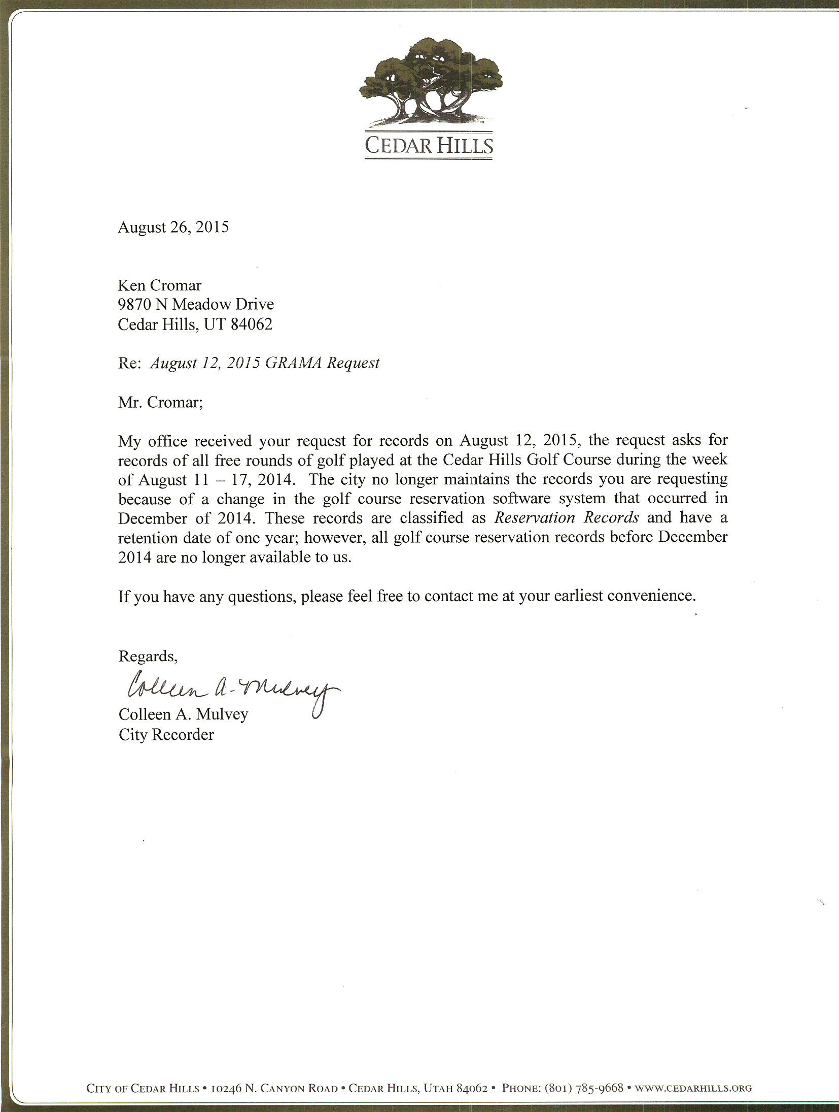

___________________________

Begin forwarded message:
From: Colleen Mulvey <cmulvey@cedarhills.org>
Subject: October 9, 2017 GRAMA Request
Date: October 20, 2017 at 12:39:41 PM MDT
To: "kencromar@bluemoonprod.com" <kencromar@bluemoonprod.com>

Ken,

Please see the attached letter regarding your October 9, 2017 GRAMA request for records.

This letter has also been mailed to you via the Post Office.

If are unable to open the attachments please let me know.

Thank you.

Colleen A. Mulvey, MMC
City Recorder
City of Cedar Hills
10246 N Canyon Road
Cedar Hills, UT 84062
(801) 785-9668 ext. 503





